ГУАП

КАФЕДРА № 43

ОТЧЕТ   
ЗАЩИЩЕН С ОЦЕНКОЙ

ПРЕПОДАВАТЕЛЬ

|  |  |  |  |  |
| --- | --- | --- | --- | --- |
| Доцент |  |  |  | С.В. Щекин |
| должность, уч. степень, звание |  | подпись, дата |  | инициалы, фамилия |

|  |
| --- |
| ОТЧЕТ О ЛАБОРАТОРНОЙ РАБОТЕ №4 |
| «Создание нескольких экранов в приложении» |
| по курсу: Программирование мобильных устройств |
|  |
|  |

РАБОТУ ВЫПОЛНИЛ

|  |  |  |  |  |  |
| --- | --- | --- | --- | --- | --- |
| СТУДЕНТ ГР. № | 4831 |  | 12.02.2021 |  | К.А.Корнющенков |
|  |  |  | подпись, дата |  | инициалы, фамилия |

Санкт-Петербург 2020

1. **Цель работы**

Освоение возможностей создания приложения с различными типами интерфейсных элементов для мобильного устройства.

1. **Задания**

Создать простое приложение c использованием различных интерфейсных элементов, размещенных на нескольких экранах (Activity) выполнить сборку и запуск приложения. Убедиться в корректном отображении интерфейсных элементов в основном окне. Описать результаты в отчете (в т.ч. тексты xml для activity).

1. **Исходный код**

<?xml version="1.0" encoding="UTF-8"?>

<document type="com.apple.InterfaceBuilder3.CocoaTouch.Storyboard.XIB" version="3.0" toolsVersion="17701" targetRuntime="iOS.CocoaTouch" propertyAccessControl="none" useAutolayout="YES" useTraitCollections="YES" useSafeAreas="YES" colorMatched="YES" initialViewController="BYZ-38-t0r">

<device id="retina6_1" orientation="portrait" appearance="light"/>

<dependencies>

<plugIn identifier="com.apple.InterfaceBuilder.IBCocoaTouchPlugin" version="17703"/>

<capability name="Named colors" minToolsVersion="9.0"/>

<capability name="Safe area layout guides" minToolsVersion="9.0"/>

<capability name="System colors in document resources" minToolsVersion="11.0"/>

<capability name="documents saved in the Xcode 8 format" minToolsVersion="8.0"/>

</dependencies>

<scenes>

<!--View Controller-->

<scene sceneID="tne-QT-ifu">

<objects>

<viewController id="BYZ-38-t0r" sceneMemberID="viewController">

<view key="view" contentMode="scaleToFill" id="8bC-Xf-vdC">

<rect key="frame" x="0.0" y="0.0" width="414" height="896"/>

<autoresizingMask key="autoresizingMask" widthSizable="YES" heightSizable="YES"/>

<subviews>

<label opaque="NO" userInteractionEnabled="NO" contentMode="left" horizontalHuggingPriority="251" verticalHuggingPriority="251" text="Hello world" textAlignment="natural" lineBreakMode="tailTruncation" baselineAdjustment="alignBaselines" adjustsFontSizeToFit="NO" translatesAutoresizingMaskIntoConstraints="NO" id="LJk-3K-tP3">

<rect key="frame" x="164.5" y="437.5" width="85.5" height="21"/>

<fontDescription key="fontDescription" type="system" pointSize="17"/>

<nil key="textColor"/>

<nil key="highlightedColor"/>

</label>

<imageView clipsSubviews="YES" userInteractionEnabled="NO" contentMode="scaleAspectFit" horizontalHuggingPriority="251" verticalHuggingPriority="251" fixedFrame="YES" image="pencil" catalog="system" translatesAutoresizingMaskIntoConstraints="NO" id="IeR-Gc-cDi">

<rect key="frame" x="87" y="278.5" width="240" height="128"/>

<autoresizingMask key="autoresizingMask" flexibleMaxX="YES" flexibleMaxY="YES"/>

</imageView>

<button opaque="NO" contentMode="scaleToFill" fixedFrame="YES" contentHorizontalAlignment="center" contentVerticalAlignment="center" buttonType="system" lineBreakMode="middleTruncation" translatesAutoresizingMaskIntoConstraints="NO" id="M7X-Wh-Kmj">

<rect key="frame" x="53" y="590" width="316" height="34"/>

<autoresizingMask key="autoresizingMask" flexibleMaxX="YES" flexibleMaxY="YES"/>

<color key="backgroundColor" name="AccentColor"/>

<fontDescription key="fontDescription" name="HiraginoSans-W6" family="Hiragino Sans" pointSize="22"/>

<state key="normal" title="Красивая кнопка">

<color key="titleColor" systemColor="labelColor"/>

</state>

<connections>

<segue destination="aQA-W1-WfR" kind="show" id="R19-ge-VHV"/>

</connections>

</button>

<button opaque="NO" contentMode="scaleToFill" fixedFrame="YES" contentHorizontalAlignment="center" contentVerticalAlignment="center" buttonType="system" lineBreakMode="middleTruncation" translatesAutoresizingMaskIntoConstraints="NO" id="QaH-eG-gKf">

<rect key="frame" x="91" y="768" width="247" height="47"/>

<autoresizingMask key="autoresizingMask" flexibleMaxX="YES" flexibleMaxY="YES"/>

<color key="backgroundColor" red="0.41888197492875501" green="0.18273269779175383" blue="1" alpha="0.51899169091464714" colorSpace="custom" customColorSpace="sRGB"/>

<fontDescription key="fontDescription" type="system" pointSize="29"/>

<state key="normal" title="Красивая кнопка 2">

<color key="titleColor" red="0.0" green="0.0" blue="0.0" alpha="1" colorSpace="custom" customColorSpace="sRGB"/>

</state>

</button>

<label opaque="NO" userInteractionEnabled="NO" contentMode="left" horizontalHuggingPriority="251" verticalHuggingPriority="251" fixedFrame="YES" text="Экран 1" textAlignment="natural" lineBreakMode="tailTruncation" baselineAdjustment="alignBaselines" adjustsFontSizeToFit="NO" translatesAutoresizingMaskIntoConstraints="NO" id="I6h-du-0sH">

<rect key="frame" x="144" y="135" width="141" height="48"/>

<autoresizingMask key="autoresizingMask" flexibleMaxX="YES" flexibleMaxY="YES"/>

<fontDescription key="fontDescription" type="system" pointSize="40"/>

<nil key="textColor"/>

<nil key="highlightedColor"/>

</label>

</subviews>

<viewLayoutGuide key="safeArea" id="6Tk-OE-BBY"/>

<color key="backgroundColor" systemColor="systemBackgroundColor"/>

<constraints>

<constraint firstItem="LJk-3K-tP3" firstAttribute="centerX" secondItem="8bC-Xf-vdC" secondAttribute="centerX" id="J8E-Ei-LQN"/>

<constraint firstItem="LJk-3K-tP3" firstAttribute="centerY" secondItem="8bC-Xf-vdC" secondAttribute="centerY" id="i37-zE-oU8"/>

</constraints>

</view>

</viewController>

<placeholder placeholderIdentifier="IBFirstResponder" id="dkx-z0-nzr" sceneMemberID="firstResponder"/>

</objects>

<point key="canvasLocation" x="114" y="70"/>

</scene>

<!--View Controller-->

<scene sceneID="yqK-R0-8nA">

<objects>

<viewController id="aQA-W1-WfR" sceneMemberID="viewController">

<view key="view" contentMode="scaleToFill" id="2ki-7X-jIZ">

<rect key="frame" x="0.0" y="0.0" width="414" height="842"/>

<autoresizingMask key="autoresizingMask" widthSizable="YES" heightSizable="YES"/>

<subviews>

<slider opaque="NO" contentMode="scaleToFill" fixedFrame="YES" contentHorizontalAlignment="center" contentVerticalAlignment="center" value="0.5" minValue="0.0" maxValue="1" translatesAutoresizingMaskIntoConstraints="NO" id="So9-Yl-gRq">

<rect key="frame" x="51" y="639" width="315" height="30"/>

<autoresizingMask key="autoresizingMask" flexibleMaxX="YES" flexibleMaxY="YES"/>

</slider>

<segmentedControl opaque="NO" contentMode="scaleToFill" fixedFrame="YES" contentHorizontalAlignment="left" contentVerticalAlignment="top" segmentControlStyle="plain" selectedSegmentIndex="0" translatesAutoresizingMaskIntoConstraints="NO" id="34l-Dk-fiv">

<rect key="frame" x="75" y="210" width="131" height="31"/>

<autoresizingMask key="autoresizingMask" flexibleMaxX="YES" flexibleMaxY="YES"/>

<segments>

<segment title="First"/>

<segment title="Second"/>

</segments>

</segmentedControl>

<textField opaque="NO" contentMode="scaleToFill" fixedFrame="YES" contentHorizontalAlignment="left" contentVerticalAlignment="center" borderStyle="roundedRect" textAlignment="natural" minimumFontSize="17" translatesAutoresizingMaskIntoConstraints="NO" id="erE-VE-1Fd">

<rect key="frame" x="141" y="378" width="97" height="34"/>

<autoresizingMask key="autoresizingMask" flexibleMaxX="YES" flexibleMaxY="YES"/>

<fontDescription key="fontDescription" type="system" pointSize="14"/>

<textInputTraits key="textInputTraits"/>

</textField>

<progressView opaque="NO" contentMode="scaleToFill" verticalHuggingPriority="750" fixedFrame="YES" progress="0.5" translatesAutoresizingMaskIntoConstraints="NO" id="SmM-qU-xBf">

<rect key="frame" x="88" y="536" width="150" height="4"/>

<autoresizingMask key="autoresizingMask" flexibleMaxX="YES" flexibleMaxY="YES"/>

</progressView>

<label opaque="NO" userInteractionEnabled="NO" contentMode="left" horizontalHuggingPriority="251" verticalHuggingPriority="251" fixedFrame="YES" text="Экран 2" textAlignment="natural" lineBreakMode="tailTruncation" baselineAdjustment="alignBaselines" adjustsFontSizeToFit="NO" translatesAutoresizingMaskIntoConstraints="NO" id="fPv-nJ-lLl">

<rect key="frame" x="155" y="83" width="145" height="48"/>

<autoresizingMask key="autoresizingMask" flexibleMaxX="YES" flexibleMaxY="YES"/>

<fontDescription key="fontDescription" type="system" pointSize="40"/>

<nil key="textColor"/>

<nil key="highlightedColor"/>

</label>

</subviews>

<viewLayoutGuide key="safeArea" id="GoZ-sC-oyA"/>

<color key="backgroundColor" systemColor="systemBackgroundColor"/>

</view>

<navigationItem key="navigationItem" id="ddX-B2-GpX"/>

</viewController>

<placeholder placeholderIdentifier="IBFirstResponder" id="M0V-Fk-Rc1" userLabel="First Responder" customClass="UIResponder" sceneMemberID="firstResponder"/>

</objects>

<point key="canvasLocation" x="1124.6376811594205" y="76.339285714285708"/>

</scene>

</scenes>

<resources>

<image name="pencil" catalog="system" width="128" height="113"/>

<namedColor name="AccentColor">

<color red="0.0" green="0.46000000000000002" blue="0.89000000000000001" alpha="1" colorSpace="custom" customColorSpace="sRGB"/>

</namedColor>

<systemColor name="labelColor">

<color white="0.0" alpha="1" colorSpace="custom" customColorSpace="genericGamma22GrayColorSpace"/>

</systemColor>

<systemColor name="systemBackgroundColor">

<color white="1" alpha="1" colorSpace="custom" customColorSpace="genericGamma22GrayColorSpace"/>

</systemColor>

</resources>

</document>

1. **Результаты работы программы**

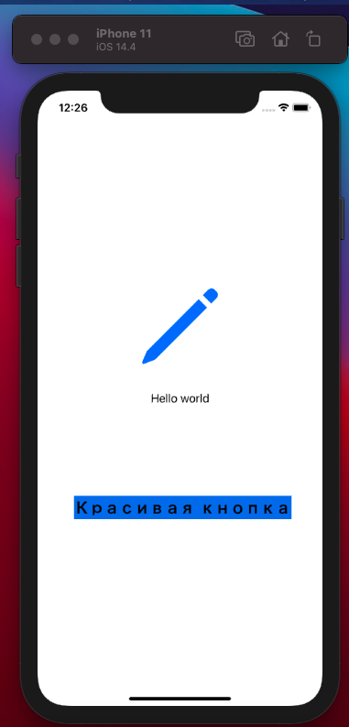

Экран 1

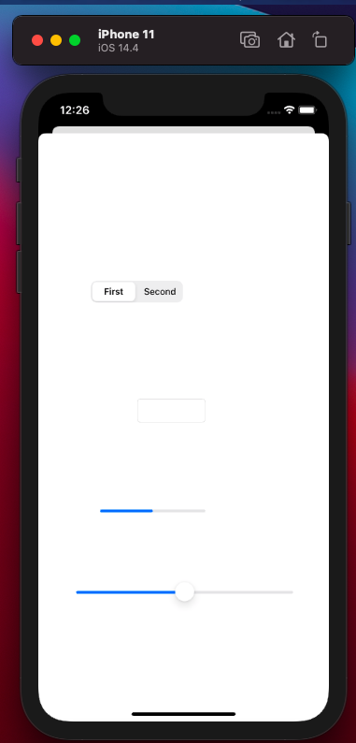

Экран 2

1. **Вывод**

В ходе выполнения лабораторной работы научились создавать дополнительные экраны.